WELCOME TO
MARVELOUS MIDDLE SCHOOL!

https://www.teacherspayteachers.com/Store/Marvelous-Middle-School

Thank you for downloading my FREE sample assignment from Teachers Pay Teachers. Included you will find several worksheets connecting to the topic of earthquakes (reading minute with questions, double puzzle page, research webquest, and math & science connection sheet). These worksheets are perfect for Grades 5-9 and work great as homework, vocabulary review, or as extra credit.

Each worksheet is provided as an MS-Word document so you can edit any questions/content to better fit the needs of your students. My middle school students are fine with the questions but if you are an elementary teacher or high school teacher then you may want to adjust the difficulty as needed.

I hope these samples give you a better idea of the quality of my work available for sale on TPT. If you take a moment to visit my store you’ll see a wide range of test/quizzes, homework, worksheets, webquests, projects, activities, and more! As of September 2016 there will be over 500 assignments available at my store with over 3,000 pages of content. Trust me, there’s something for everyone.

As a National Board Certified Teacher, my specialty is on science. Some of the major sections of my store include: Animals / Ecosystems, Forensics, Space / Planets, Periodic Table of Elements, Weather, Human Body, Vocabulary, and Web Quests.

There is also a wide selection of video worksheets to enjoy including: Bill Nye, Man vs. Wild, Mythbusters, Forensic Files, I Shouldn’t Be Alive, and More!
Again, thank you for your initial download and for taking the time to leave me positive feedback. I hope you’ll also visit my store! Have a great day!


*Marvelous Middle School*

EARTHQUAKE PUZZLE PAGE
VOCABULARY CRISS-CROSS

NAME- ___________________________________ HOUR - _______

DIRECTIONS: DETERMINE THE CORRECT PLACEMENT FOR THE KEY EARTHQUAKE VOCABULARY TERMS IN THE GRID BELOW.

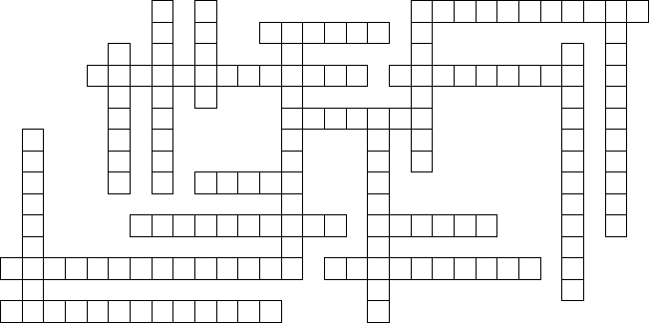

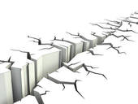

5 Letters  focus  fault  6 Letters  stress  tremor  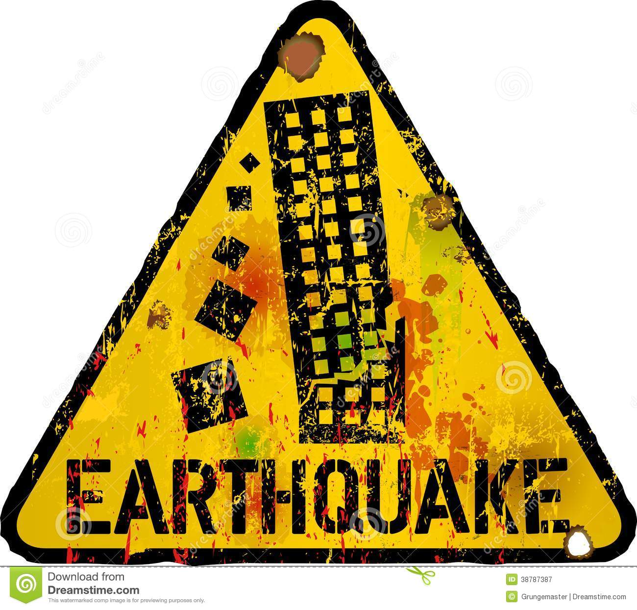  7 Letters  tension  tsunami  8 Letters  shearing | 9 Letters  epicenter  fault zone  magnitude  10 Letters  geophysics  aftershock  earthquake  11 Letters  seismograph  primary wave | 12 Letters  Richter Scale  seismologist  13 Letters  secondary wave  Mercalli Scale  14 Letters  subduction zone

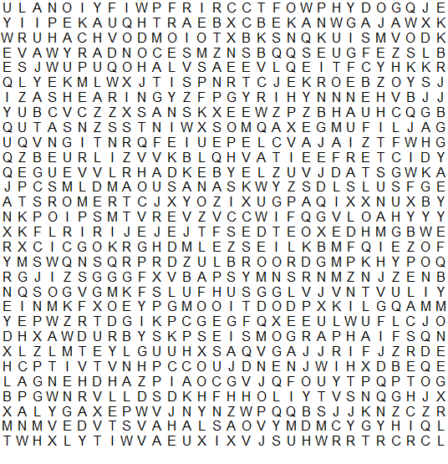
EARTHQUAKE PUZZLE PAGE
VOCABULARY WORDSEARCH

DIRECTIONS:
FIND THE 20 EARTHQUAKE TERMS IN THE WORDSEARCH

aftershock
earthquake
epicenter
fault
fault zone
focus
geophysics
magnitude
Mercalli Scale
primary wave
Richter Scale
secondary wave
seismograph
seismologist
shearing
stress
subduction zone
tension
tremor
tsunami

EARTHQUAKE PUZZLE PAGE
ANSWER KEY

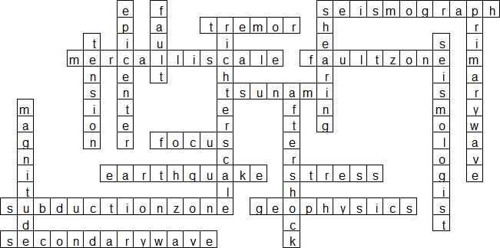



READING MINUTE QUESTIONS
STUDENT NAME - _____________________________________ HOUR - _____
1) Look over the article and identify ten (12) science vocabulary words.
Circle or highlight the words in the article and then write the word below.
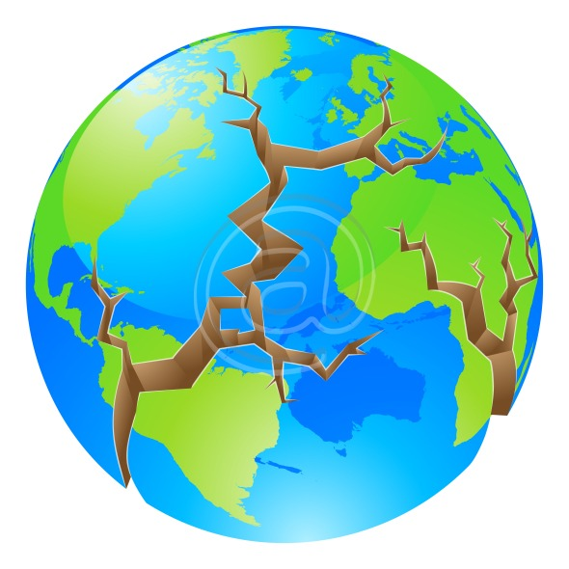
1 - ______________________________ 7 - ____________________________
2 - ______________________________ 8 - ____________________________
3 - ______________________________ 9 - ____________________________
4 - ______________________________ 10 - ____________________________
5 - ______________________________ 11 - ___________________________
6 - ______________________________ 12 - ___________________________
2) Explain two specific disasters that earthquakes can cause.
1 - __________________________________________________________________
2 - __________________________________________________________________
3) What is the Pacific Ring of Fire and how is it connected to earthquakes?
___________________________________________________________________________
___________________________________________________________________________
4) Explain two historical events mentioned in the reading minute.
___________________________________________________________________________
___________________________________________________________________________
5) What materials are best used for building homes to protect against earthquakes?
___________________________________________________________________________
6) What is the different between a mainshock and an aftershock? ________________________
___________________________________________________________________________
7) Summarize this article in one science sentence. Underline two key terms in the sentence.
__________________________________________________________________________________
__________________________________________________________________________________
SCIENCE READING MINUTE
Earthquake Facts & Information

The field of science called seismology focuses on the study of earthquakes. Scientists called seismologists are constantly studying the causes and factors that can create some of the most powerful and destructive natural disasters on our planet. An earthquake is simply the shaking of the Earth’s surface. Sometimes this shaking can’t be felt at all by humans. Other times the shaking is so intense that it can topple buildings in seconds.
Most earthquakes happen along the edges of Earth's tectonic plates. An area of our planet called the Pacific Ring of Fire is where a number of the most active tectonic plates can be found. It is in the Ring of Fire where 80% of earthquakes occur. Sometimes there are many small earthquakes before the most powerful one strikes. These small ones are called foreshocks. The biggest earthquake is called the mainshock. This quake releases the most energy and will cause the most damage. However that doesn’t mean it will last for a long period of time. Some mainshocks are only a few seconds while others can last minutes. Once the mainshock has ended, small quakes may follow which are called aftershocks. An aftershock can occur hours, days, or even weeks after the mainshock.
Many earthquakes have been known to cause a volcanic eruption if a volcano is within range. Sometimes earthquakes happen on the ocean floor. Big ocean waves can form after a quake resulting in what is called a tsunami. The shaking of the ground is not what kills most victims of earthquakes. The main killers in earthquakes are falling buildings, fires, landslides, avalanches and tsunamis. The deadliest known earthquake in history shook China in 1556, taking about 830,000 lives. The most powerful earthquake ever recorded struck Chile in 1960 and measured a 9.5 on the Richter Scale (a system of measuring earthquakes).
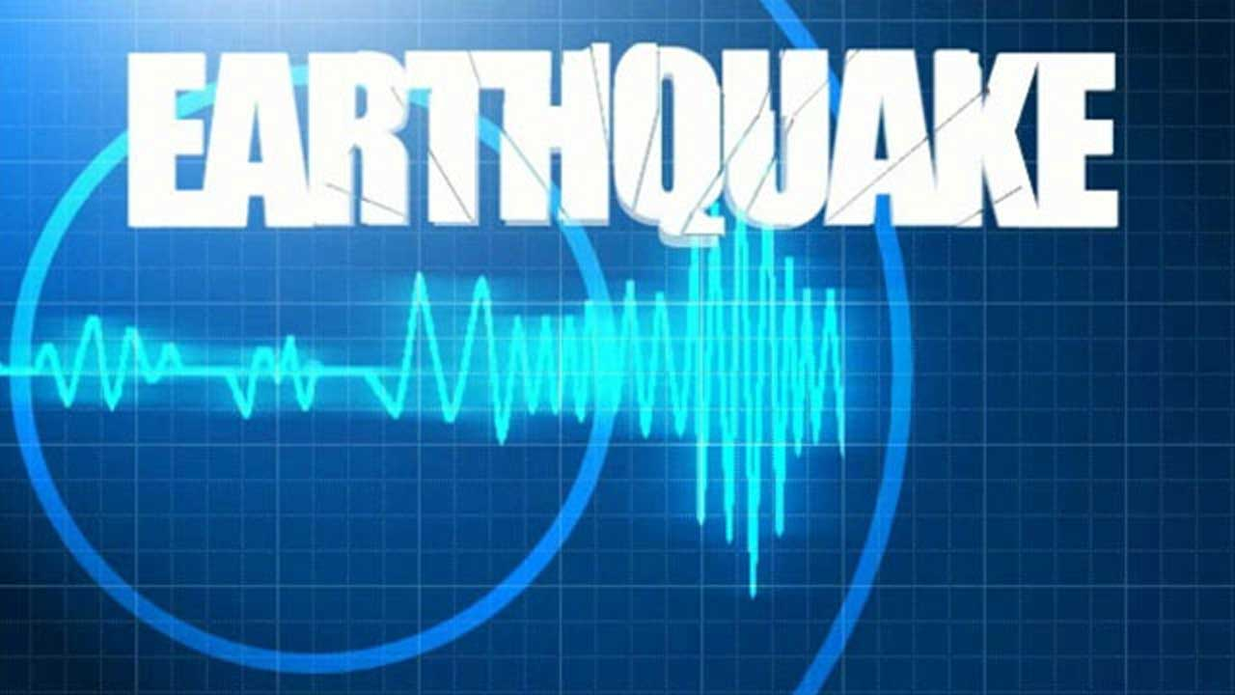
Each year there are over a million earthquakes on our planet. But the majority are so small in power that we never notice them. Only about 100 earthquakes a year amount to damage. Still, with an earthquake happening every thirty seconds, scientists and engineers are constantly working on monitoring technology and designing safer structures to help protect people from earthquakes. Steel, reinforced concrete and wood are good building materials for an earthquake resistant house because they flex somewhat without breaking. Family homes built completely out of brick are not as safe because they can break apart easily under the power of an earthquake.

SCIENCE WEBQUEST
FAMOUS EARTHQUAKES
Name - _____________________________________________ Hour - ______

Directions: Look up 4 of the famous earthquakes below and fill in the required information.
We will share the information together in class, so choose facts that you understand.

Japan (1923) Soviet Union (1948) Italy (1908)
Pakistan (2005) Azerbaijan (1667) China (2008)
China (1290) Iran (1721) Portugal (1755)
Peru (1970) Italy (1693) Iran (1990)
Turkey (1990) Japan (1498) Nepal (2015)

1) Earthquake - _________________________________

Specific Location - ______________________________ Magnitude - ___________

Fact 1 - ______________________________________________________________________

____________________________________________________________________________

Fact 2 - ______________________________________________________________________

____________________________________________________________________________

Why is this considered one of the worst earthquakes in history? _________________________

____________________________________________________________________________

____________________________________________________________________________

2) Earthquake - _________________________________

Specific Location - ______________________________ Magnitude - ___________

Fact 1 - ______________________________________________________________________

____________________________________________________________________________

Fact 2 - ______________________________________________________________________

____________________________________________________________________________

Why is this considered one of the worst earthquakes in history? _________________________

____________________________________________________________________________

____________________________________________________________________________
3) Earthquake - _________________________________

Specific Location - ______________________________ Magnitude - ___________

Fact 1 - ______________________________________________________________________

____________________________________________________________________________

Fact 2 - ______________________________________________________________________

____________________________________________________________________________

Why is this considered one of the worst earthquakes in history? _________________________

____________________________________________________________________________

____________________________________________________________________________

4) Earthquake - _________________________________

Specific Location - ______________________________ Magnitude - ___________

Fact 1 - ______________________________________________________________________

____________________________________________________________________________

Fact 2 - ______________________________________________________________________

____________________________________________________________________________

Why is this considered one of the worst earthquakes in history? _________________________

____________________________________________________________________________

____________________________________________________________________________

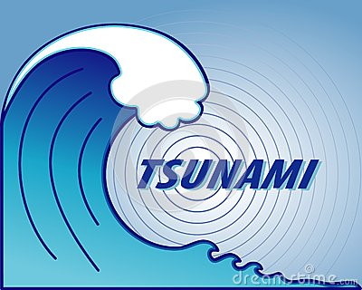
5) Now look up the 9 worst tsunamis in recorded history.
Below write the main location name and date when each struck.

1) Main Location - _______________________________ Date - _____________
2) Main Location - _______________________________ Date - _____________
3) Main Location - _______________________________ Date - _____________
4) Main Location - _______________________________ Date - _____________
5) Main Location - _______________________________ Date - _____________
6) Main Location - _______________________________ Date - _____________
7) Main Location - _______________________________ Date - _____________
8) Main Location - _______________________________ Date - _____________
9) Main Location - _______________________________ Date - _____________

EARTHQUAKES & MATH
USING THE RICHTER SCALE
Name - ________________________________________ Hour - ___________

DIRECTIONS: USE THE EARTHQUAKE RICHTER SCALE DATA TO ANSWER
THE MATH ITEMS FOR EACH PROBLEM.

1) TEN MEASURED INLAND EARTHQUAKES.

1.0 | 2.5 | 3.5 | 2.5 | 2.4 | 1.7 | 2.5 | 3.4 | 3.4 | 2.9

Determine the following items based on the data for these California earthquakes.

RANGE = _______ MEAN = _______ MEDIAN = _______ MODE = _______

2) LAST TEN MEASURED ALASKA EARTHQUAKES.

7.6 | 7.7 | 7.6 | 5.0 | 5.2 | 5.1 | 7.6 | 6.6 | 6.4 | 4.8

Determine the following items based on the data for these California earthquakes.

RANGE = _______ MEAN = _______ MEDIAN = _______ MODE = _______

3) LAST TWENTY MEASURED CALIFORNIA EARTHQUAKES.

3.8 | 3.0 | 2.6 | 4.1 | 3.0 | 4.2 | 4.3 | 5.5 | 5.0 | 6.1
4.2 | 3.4 | 2.9 | 5.1 | 5.5 | 3.3 | 4.8 | 4.2 | 4.3 | 2.7

Determine the following items based on the data for these earthquakes.

RANGE = _______ MEAN = _______ MEDIAN = _______ MODE = _______

4) LAST TWENTY MEASURED ASIA EARTHQUAKES.

7.8 | 8.1 | 3.3 | 6.6 | 8.1 | 7.2 | 7.7 | 5.0 | 5.0 | 4.2
5.0 | 3.9 | 4.4 | 5.0 | 2.1 | 1.7 | 1.9 | 5.5 | 5.8 | 8.0

Determine the following items based on the data for these earthquakes.

RANGE = _______ MEAN = _______ MEDIAN = _______ MODE = _______

5) LAST TWENTY MEASURED INDONESIA EARTHQUAKES.

6.8 | 6.0 | 5.9 | 5.6 | 5.4 | 5.3 | 4.9 | 4.7 | 4.1 | 4.1
4.1 | 3.9 | 3.9 | 3.7 | 3.6 | 3.3 | 3.3 | 2.8 | 2.5 | 1.7

Determine the following items based on the data for these earthquakes.

RANGE = _______ MEAN = _______ MEDIAN = _______ MODE = _______

